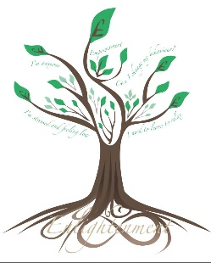
SEVEN TOP TIPS TO HELP EMPOWER YOURSELF TO KEEP WORKING & ENJOYING LIFE

Often your confidence can take a knock because of having time off work due to an accident, illness, issue at work or bereavement. The build up of stress from your life and anxiety about returning to work can be incredibly challenging. The longer you are off work though, the more likely you are to never return to work. This is where you need to make a decision and get support to help you stay in work as you will have a more fulfilling life by doing so. There is support available to help you.

According to latest research in July 2023 by the Joint HMT-HMRC consultation on tax incentives for occupational health, the following are now the current reality post lockdown.

- Long term sickness is the main reason for economic inactivity currently
- Cost of losing an employee to an employer is estimated at £8000
- Cost of someone leaving the workplace and moving onto long term sickness benefits is estimated to cost the UK between £18000 and £36000.

Lockdown had a major impact on many individuals young and old and this has affected people’s confidence and has made people rethink their priorities. Long term sickness costs the Government and employers a huge amount of money and therefore it is in their interests to support you if you feel you have a disability or physical or mental health condition.

Key issues you may have:

- Mental Health issues – diagnosis of a condition or you suspect you have one
- Physical disability e.g. sight loss, hearing loss, mobility issues, etc
- Neuro diversity – ADHD, Dyslexia, Dyscalculia, Dyspraxia, Autism,

It is time for you to work out why you are feeling disempowered and to make a change in your life as there is support available for you but you maybe hadn’t realised until now.

There are 7 steps to becoming empowered again…..

E mpowerment – get over all your issues and just be you
When you lose your confidence and are feeling disempowered, it is so easy to give up. You may have been told by a health professional that you have lost the ability to do something in life going forward or your mental health has been so out of kilter that you are embarrassed about going back to work and seeing people again.

It is actually a time to intend that things are going to get better and to be positive. Sometimes health professionals aren’t right in their predictions and only you can work through issues to get your health back. You may have to dig deep and use some empowerment techniques but it is possible to become empowered and confident once more. Transform your fears into love. Love yourself more and value yourself as a person. Know that you are good enough. Work is a massive part of your life and being paid to do a days work and helping others through your work is hugely beneficial to your health and will give you a purpose.

M aintain your confidence levels by staying empowered and supported
Confidence is like a muscle. You have to be continually facing your fears and stepping out of your comfort zone to stay confident. If you remain complacent and don’t face your fears, you will become too rigid and static and have a fixed mindset. It is so easy to tell yourself that you just aren’t good enough and to talk yourself out of sorting out your fears and the pain that you might be feeling.

If you want to go back to work (or stay in work but help to stop you from struggling), you need a flexible, growth mindset. Often we don’t like to ask for help, but actually this is a time to ask for help from others including your employers, friends and family. They might not even realise that you are struggling.

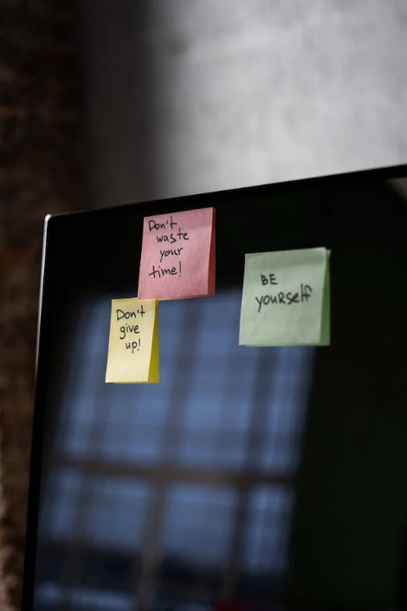
P ersevering and not giving up
When you have had a knock or two and life isn’t feeling too good, it is easy to doubt yourself and your abilities. Confidence can go down and you feel useless and undervalued. It is so important that you make a decision to persevere in getting your health and happiness back and not giving up on being able to work. The longer you are off, the harder you will find it to go back. You may feel abandoned by work colleagues and your employers as no one has checked on you, but remember they may not be contacting you as they don’t want to harass you whilst you are off sick.

You may not be able to do the work you did before, in the way you did, but you are a valuable individual and you will have transferable talents which could be used in other ways. Persevere and new opportunities will open up for you.

O pportunities opening up
When you have decided to become more empowered and no longer the victim in what is going on in your life, you will notice that new opportunities will open up for you. The Universe will show you new ideas for you using your talent and wisdom in ways that you may never have thought of yourself. Whilst what has lead you to this point has been challenging, your resilience and strength getting through this time is hugely empowering and inspirational to others.

Take time out to slow down, meditate and to ask yourself about what would help you to be able to work again. What equipment may you need? What support may you need? Were you in your ideal job before or would a change make a big difference to your happiness.

W ealth – remember your health is your wealth
Taking time off work can have a real knock to your finances. You may of course get some form of sick pay initially, but when this goes, you might have to become more reliant on Government benefits. Your money mindset is key at this time and you want to learn now to be savvy with your money. The more you focus on your money – budgeting, saving etc and keep working on your health and getting better, you will find that your finances will steadily improve. If you ignore your finances, put your head in the sand and start running up debts because you aren’t feeling happy, this can have a massive impact on your mental health and self worth and you will find it harder to bounce back.

If you are finding it hard to manage your money or to deal with your debt, there are charities like Step Change and Martin Lewis who support those in financial difficulty. You may also like to read my book ‘Are you worth it? A spiritual guide to managing your money mindset’ to help you change your mindset or come on my free Money Mindset Workshop.

Energy – keep energised and positive and life will get better
Trying to stay positive all of the time can be really tiring. Yes, negative things happen in life, but it is how you traverse these times which make you stronger and more resilient. Understanding your energy is really important – whether you are feeling high or low, positive or negative, etc. When we are going through the challenges, then it can feel like we are walking through treacle at times. Dealing with your emotions is essential and training your mind to stay in the present and to let go of the past. Past trauma or negative patterning within you might be stopping you from moving forward or you might just feel stuck. It maybe causing you to procrastinate too. Keep shifting your energy to get joy and pleasure from simple things in life.

Sometimes when we are stuck in life, it is because we are bored. We need to connect to what we are passionate about, to raise our energy and to stay positive. Sometimes the negative emotions within us are linked to how we judge ourselves and others so developing a non judgemental attitude towards yourself and others can be useful at all times. Stop comparing yourself to others too.

R eaffirm who you are and get passionate about helping others
Sometimes we forget who we really are and where we are going in life. We can lack direction and enthusiasm. We can also become too sensitive and judgemental. The only person who can change the direction of your health is you. Start loving and valuing yourself more. Apply more self care routines and be kind to yourself and others. When you are in a better place, you will probably realise that you want to help others. Even if this is volunteering initially if you don’t feel ready to go fully back to work.

Being passionate about helping and serving others will invoke your life purpose and you will be happier and healthier for it. By helping others, you will take your mind away from your troubles and pain and will inspire and empower others around you.

Are you ready to access Government funding to help you to make this transformation?

The scheme which can support you is called Access to Work. Access to Work has been a service available for many years, however you may never have heard of the support you may receive. You can receive up to £66000 towards equipment, support workers and work place coping strategy coaching for neuro diversity dependent on your needs.

Access to Work will support you in the following ways.
- a grant to help pay for practical support with your work
- support with managing your mental health at work
- money to pay for communication support at job interviews

Sometimes your employer will pay a contribution towards equipment or services that you need as they are still expected to make reasonable adjustments for you at work under the Equality Act 2010.

For more information about how to apply and to see if you are eligible go to: https://insightfulminds.co.uk/access-to-work-funding/

