Morning ritual, affirmations and gratitudes

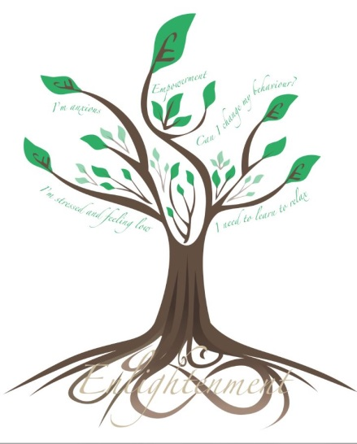
Every morning as I wake, I vision my new day as I want it to be, say at least ten things that I am grateful for and look at my goals and say them out aloud. I also say these specific affirmations, and gratitudes.

I am in control
I am calm
I am a valuable person
I am rich, I am deeply loved, I am worthy
I can handle anything today brings
I am always in the right place at the right time
I am always presented with new opportunities to better myself
I am perfect in every way
Great things always happen around me
My place of work is a harmonious place to work
My client base is increasing fast
Money flows often and easily to me
I always have more than enough money
My workshops are oversubscribed and my business easily attracts paying clients

I am grateful of the world and it’s magic
I am grateful of the people in my life
I am grateful of bad times as they make me appreciate good times
I am grateful of my body and it’s ability to get me through the day with little or no appreciation for the magical way it works
I am grateful of my good health

Thank you, thank you, thank you for connecting me with who I need to be connected with today.

I am abundant in every good way. Infinite money is mine to earn, save, invest and exponentially multiply and share. My abundance is making everyone better off. I embrace abundance and abundance embraces me.

I now recognise my creativity and I honour it
Love is all I need to fix my world
I communicate with love and attract loving experiences and people to me
I appreciate the beautiful world I live in
My thoughts weave the tapestry of my life
I give myself permission to prosper
I am always willing to take the next step
I connect with the Power that created me
I am in the rhythm and flow of an ever changing life
My love and acceptance of others creates lasting friendships
I bless others good fortune and know that there is plenty for all
The love I give is the love I receive

