Anita White’s story….. Another Reiki success….

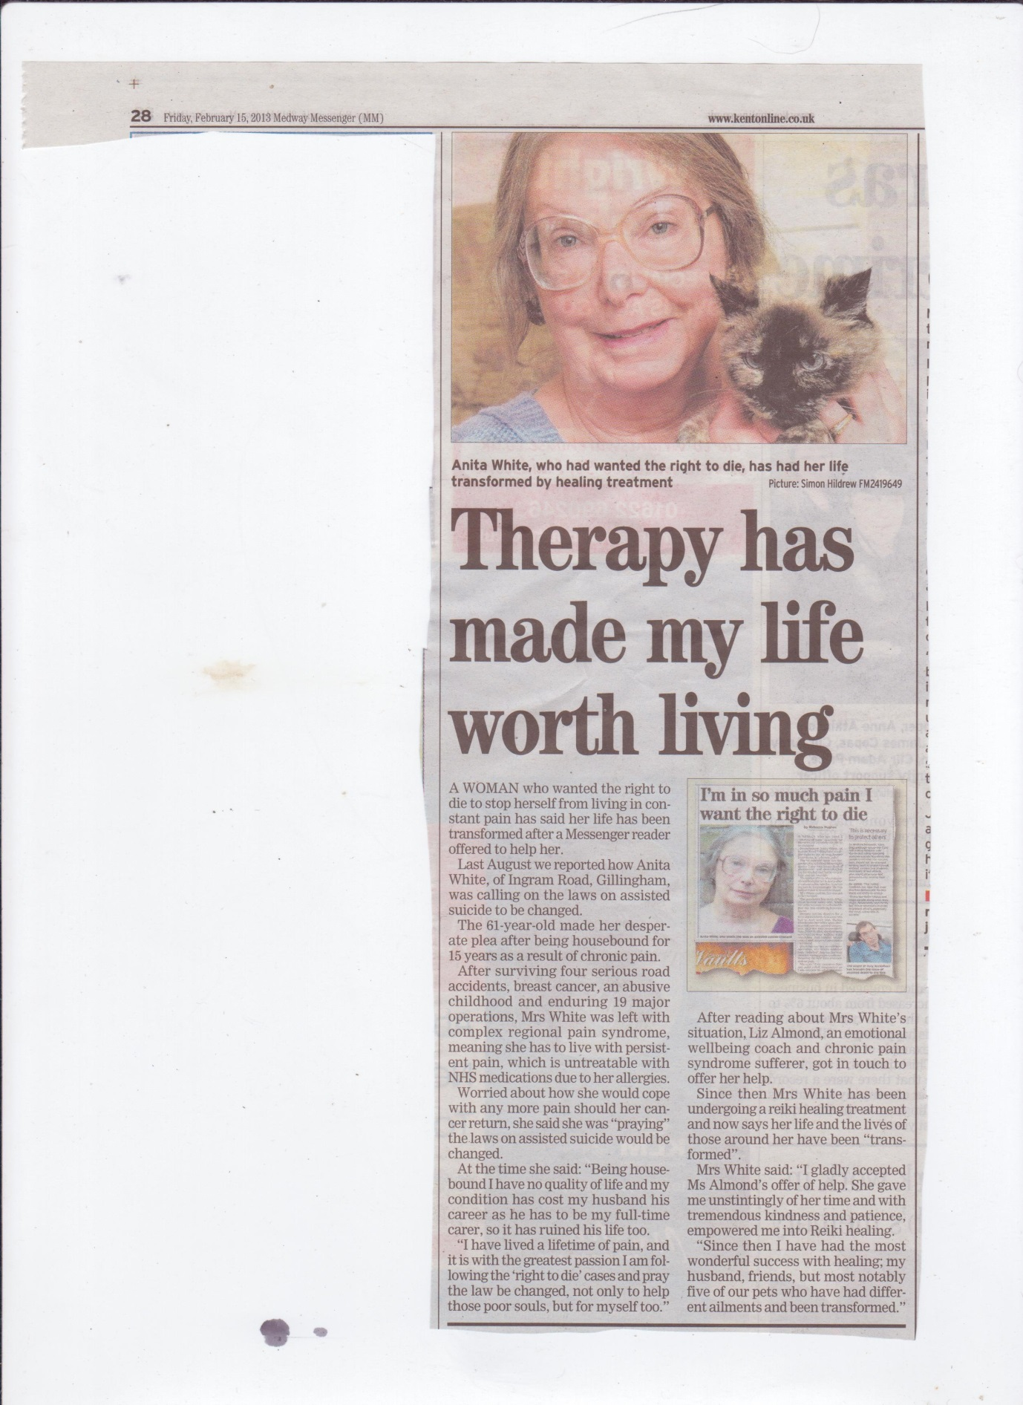

For more help exploring the issues you have, contact Liz Almond, Insightful Minds by ringing 07815 904848 or emailing Liz at liz@insightfulminds.co.uk

